Project Planning Phase

Project Planning Template (Product Backlog, Sprint Planning, Stories, Story points)
Date | 04 July 2026
Team ID | SWTID-2026-4563
Project Name | Visualizing Housing Market Trends: An Analysis of Sales Price and Features Using Tableau
Maximum Marks | 5 Marks

Product Backlog, Sprint Schedule, and Estimation (4 Marks)
Use the below template to create product backlog and sprint schedule
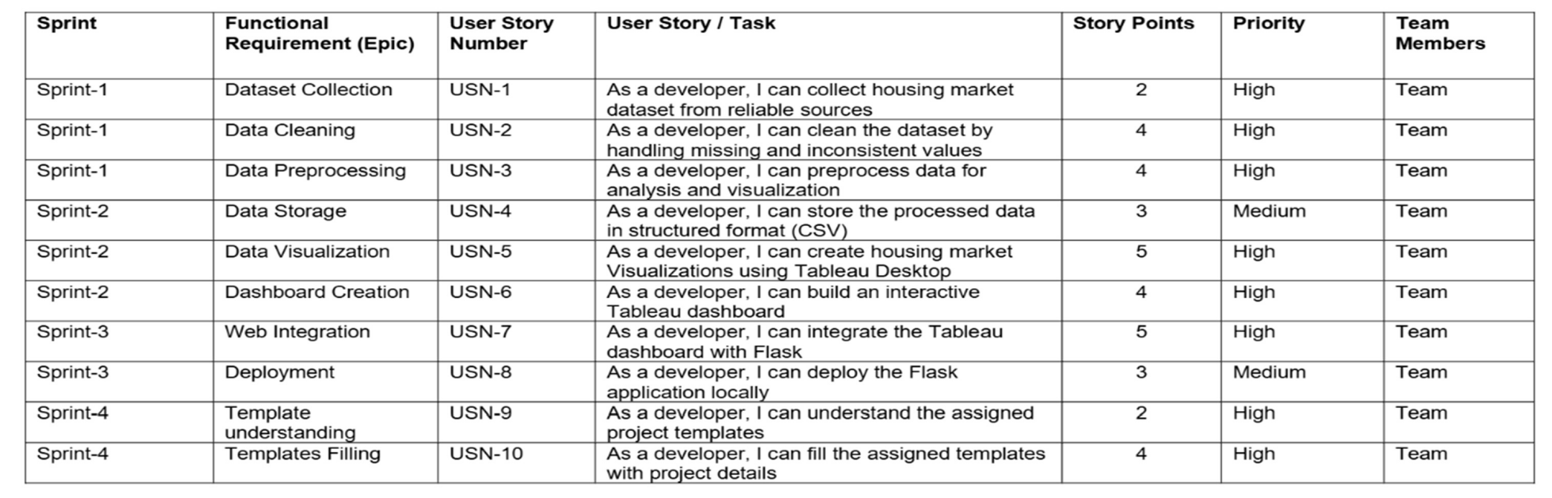

Project Tracker, Velocity & Burndown Chart: (4 Marks)
